Grand Ledge Public Schools
Virtual Meeting of the
Board of Education

Please take notice that the Board of Education will hold a Virtual Meeting on:

Date: Monday, September 14, 2020

Place: Executive Order 2020-160 limits statewide indoor gatherings to 10 people or less. This requires the Grand Ledge Public Schools Board of Education to meet electronically.

Join the Meeting: https://us02web.zoom.us/j/84084408721
Meeting ID: 840 8440 8721
One-tap mobile:
+19294362866,,84084408721# US (New York)
+13017158592,,84084408721# US (Germantown)
Dial by your location:
+1 929 436 2866 US (New York)
+1 312 626 6799 US (Chicago)
More phone numbers at: https://us02web.zoom.us/u/kpLqnmlVO

Time: 6:00 p.m.

Purpose: General Business

Board minutes are located at the Board of Education office, 220 Lamson Street, Grand Ledge, MI 48837

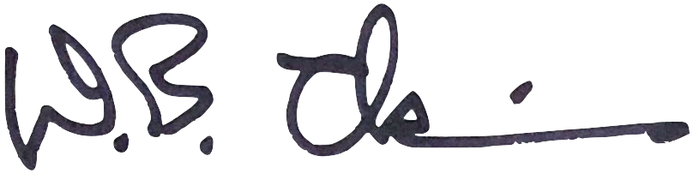
Dr. David Chapin, Interim Superintendent of Schools

cc: Buildings
Board Members
Lansing State Journal
Grand Ledge Independent
Greg Almy, President GLEA
Cindy Zerbe, President, MEA/NEA Unit I, Secretarial /Clerical
Karen Shaw, President, MEA/NEA Unit III, Food Service
Jennifer McCrumb, President, MEA/NEA Unit IV, TA/HC/Bus Assistants & Adv. Club
Kara Bond, President, IUOE Local 547, A, B, C, E & H AFL-CIO, Bus Drivers
Ron Hicks, President, Custodial Association

Date of Posting: September 9, 2020

NOTE: Individuals may address the Board for up to three (3) minutes in the Public Comment segments of the meeting. Those representing a group, present at the meeting, are allocated additional time.

Any person with a disability needing accommodations to participate in this Board of Education meeting should contact Kim Manning at 925-5401 or by eMail at manningk@glcomets.net at least one (1) business day prior to the date of this meeting.

